Application
Post-Graduated Courses – 2025/2026
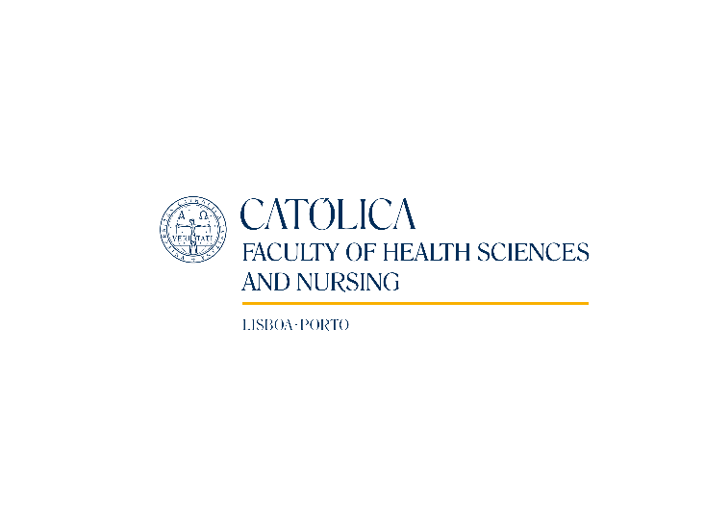

Post-Gradution on
Lisbon Series on PALLIATIVE CARE
In Depth reviews for Palliative Care and non Palliative Care Health Professionals:

Focus on Non-Cancer Patients

Student Number _________________________
(University filling)

PERSONAL INFORMATION
Full Name:
Birth Date:
Adress:
Zip Code: | - | Region:
VAT number:
ID card: | N.º
 | Expiration date:
Phone number: | E-mail:

ACADEMIC INFORMATION
Undergraduate degree | Other degree?
Conclusion year:

CONDITIONS
Enrollment fee – 115,00 € (Payed after admission with 1st monthly fee)
Payments
Total – 1 900,00€
Monthly payments (5 payments of 380,00€ each)

PAYMENT
After receiving the application form, will be sent a confirmation e-mail with further instructions.

Do you want the receipt:
on your own name
in the name of:

Send your application form as well as copy of your ID card to:
Faculty of Health Sciences and Nursing  Universidade Católica Portuguesa  Edifício da Biblioteca João Paulo II – 5º Piso  Palma de Cima, 1649-023 Lisboa  Further information at: www.fcse.lisboa.ucp.pt | or | saude.sede@ucp.pt

How did you know about this course?
Through:

1. Professors and Staff from FCSE
2. Internet/mail:
2.1. Mail sent by FCSE
2.2. ICS Website (UCP)
2.3. Facebook
2.4. Google
3. Current Student:
4.1. From Faculty of Health Sciences and Nursing
4.2. From other Faculty of UCP
4. Alumni:
4.1. From Faculty of Health Sciences and Nursing
4.2. From other Faculty of UCP
5. Other:
5.1. Work Collegues
5.2. Friends and family
6. Other (please, explain)

[ Date ]

