|  |  |
| --- | --- |
|  | Application  **Post-Graduated Courses – 2024/2025** |

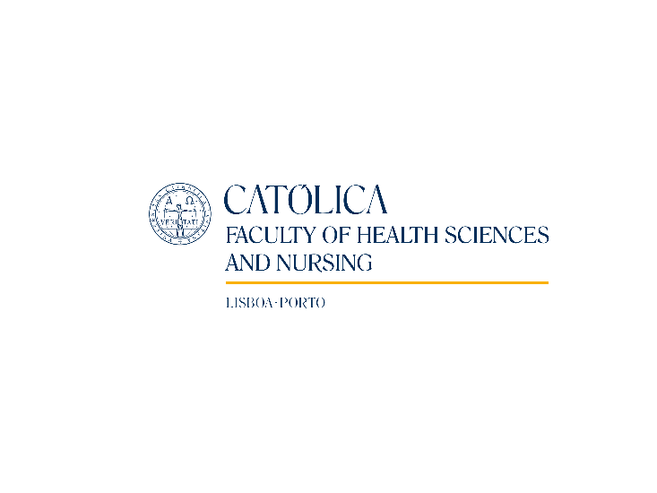  
Post-Gradution on   
Lisbon Series on PALLIATIVE CARE  
**In Depth reviews for Palliative Care and non Palliative Care Health Professionals:**

**Focus on Non-Cancer Patients**

*Student Number* _________________________

(University filling)

**PERSONAL INFORMATION**

|  |  |  |  |
| --- | --- | --- | --- |
| **Full Name:** |  | | |
| **Birth Date:** |  | | |
| **Adress:** |  | | |
| **Zip Code:** | - | **Region**: |  |
| **VAT number:** |  | | |
| **ID card:** | N.º | | |
|  | Expiration date: | | |
| **Phone number:** | E-mail: | | |

**ACADEMIC INFORMATION**

|  |  |
| --- | --- |
|  | Undergraduate degree       | Other degree?  Conclusion year: |

**CONDITIONS** **Enrollment fee – 110,00 €** (Payed after admission with 1st monthly fee)  
 **Payments**

Total – 1 900,00€

Monthly payments (5 payments of 380,00€ each)

**Certificate – 95,00 €**



**PAYMENT**

After receiving the application form, will be sent a confirmation e-mail with further instructions.

**Do you want the receipt:**

on your own name

in the name of:      

**Send your application form as well as copy of your ID card to:**

|  |  |  |
| --- | --- | --- |
| Faculty of Health Sciences and Nursing  Universidade Católica Portuguesa  Edifício da Biblioteca João Paulo II – 5º Piso  Palma de Cima, 1649-023 Lisboa  **Further information at:** [www.fcse.lisboa.ucp.pt](http://www.fcse.lisboa.ucp.pt) | ***or*** | [saude.sede@ucp.pt](mailto:saude.sede@ucp.pt) |

## How did you know about this course?

Through:

1. Professors and Staff from FCSE

2. Internet/mail:

2.1. Mail sent by FCSE

2.2. ICS Website (UCP)

2.3. Facebook

2.4. Google

3. Current Student:

4.1. From Faculty of Health Sciences and Nursing

4.2. From other Faculty of UCP

4. Alumni:

4.1. From Faculty of Health Sciences and Nursing

4.2. From other Faculty of UCP

5. Other:

5.1. Work Collegues

5.2. Friends and family

6. Other (please, explain)

[ Date ]